ΠΑΡΑΡΤΗΜΑ 2^{ο} – ΜΑΘΗΜΑ ΚΑΤΑΝΟΗΣΗΣ ΠΡΟΦΟΡΙΚΟΥ ΛΟΓΟΥ

Lesson Plan of the Listening Lesson -based on Harmer’s suggestions (Harmer, 1991)

Students

Class of 25-30 students, age range 13-14.

Level: Intermediate level

Time available : 45’ – the class takes place three times a week.

Teaching materials : Think Teen – 1st Grade of Junior High School- ΠΡΟΧΩΡΗΜΕΝΟΙ (p.104).

Main Aim

Teaching Listening as a skill. Reinforcement of several listening strategies (inferencing, monitoring, predicting).

Assumptions

Ss have already been exposed to the specific genres involved. They already know lots of words in relation to travelling. They possess certain real-world knowledge, i. e. where Fontana di Trevi is (or could be on the basis of its pronunciation!)

Teaching aids : The blackboard, relevant tasksheets.

Language: Past Simple and vocabulary on “travelling”.

The stages of the lesson

PRE-LISTENING

Steps Objectives Time-Interaction
1.Students are asked to think to introduce the topic 2’ - Ss
of words relating to and arouse Ss’ interest
“travelling”
2. Students are asked to do to bring the particular lexis 3’ – T- Ss- T
an acrostic on travelling to students’ short-term memory
travelling words. Eliminate differences on L2
(with the teacher’s help) competence among Ss
3.students are given 5 photos to draw student’s interest 5’ - Ss
and invited to recognise the and elicit the names of
particular places. Then, in groups several places that are to occur
come up with other places the 1st listening task
related to a specific photo.

1st Part of the listening input

WHILE-LISTENING

Steps Objectives Time-Interaction
1.Ss have to fill in the missing to listen carefully for specific 5’ – Ss-Ss
information about three details and participate in a
holiday offers.
2.Students are asked to come up to elicit the appropriate structures 2’ –T- Ss- T
with questions they would ask in for the following information-gap
relation to the missing information task
3. Ss get involved in an information- to have Ss involved in a pseudo- 5’- Ss (T acts like
gap activity with another fellow communicative task of asking for a guide)
student to check their answers providing information

POST-LISTENING

Steps Objectives Time-Interaction
1. Ss are to imagine they had to arouse particular 2’ –T- Ss
been to one of the 3 cities utterances that are likely
and are asked to write something to occur in the 2nd input
they did while they were there
2.Ss are asked to predict where I arouse their interest&curiosity 1’ - Ss
went on holiday based on the make the 2nd input
information of the previous table purposeful for them

2nd Part of the listening input

WHILE-LISTENING

Steps Objectives Time-Interaction
1.Ss read quickly 4 open-ended activate such listening strategies 7’- 8’ – T- Ss -T
questions and listen to the input as inferencing and predicting and
to find or infer the answers make them realise what strategies
they had employed

POST-LISTENING

Steps Objectives Time-Interaction
1.Ss read quickly an e-mail and have students make an inference 5’- T- Ss
identify two people referred to based on the style of the text and
in it on data present in the text.
2. Students are to take up the part empathise students and have them 8’- T- Ss
of the persona present in the create an authentic informal e-mail
listening input and write an
e-mail similar to the one included
in the previous task (in pairs)
Additional Possibilities

- If boys resist to pretend to be Christina in the last writing task, I will tell them to pretend to be Kostas.
- Assign another writing task on “narrating an unexpected meeting while being on holiday”.

Possible Difficulties

- Students trying to “cheat” and look at other students tasksheets while doing the information gap task.
Possible solution: not permitting them to walk round the classroom to ask their fellow students; telling them to do that from their seats.

The tasksheets

H O L I D A Y S

Task 1
Do the following acrostic with words related to travelling.

1.
1. _ _ _ _ a short journey for pleasure
2. _ _ _ _ _ _ travel ______ = travel to a foreign country
3. _ _ _ _ _ _ _ _ another word for “holidays”
4. _ _ _ _ Kosta has a great ... of Spetses.You can gaze for hours!
5. _ _ _ _ _ a place that provides accomodation and meals.
6. _ _ _ _ _ _ _ the opposite of departure.
7. _ _ _ _ _ people go on holiday in order to...
8. _ _ _ _ _ _ _ _ _ _ _ visiting the sights of a place
9. _ _ _ _ _ _ _ _ _ means of taking people from one place to another
10. _ _ _ _ _ _ you go to a travel ...to book a holiday.

Which word is formed under 1? _______________________

Task 2
- Which of the landmarks in the following photos do you recognise? In which countries are they?
- Make a list of things / places related to each photo. (Write them under each photo)

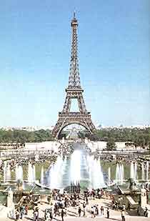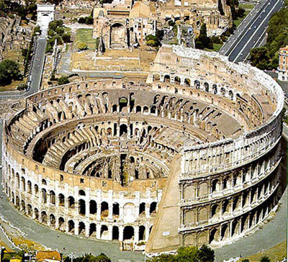

______________________ _____________________
______________________ _____________________
______________________ _____________________
______________________ _____________________
______________________ _____________________

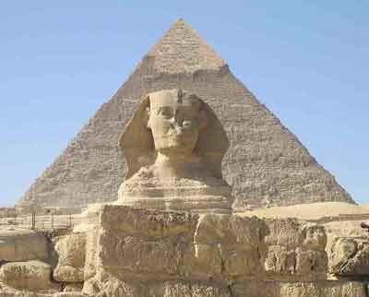

______________________
______________________
______________________
______________________
______________________

Task 3 (Student A)
Last year I went on holiday abroad. Before deciding where to go, I got some travel brochures for three different 5-day trips to Cairo, Rome and Paris. Now, you are going to listen to these three holiday offers I had. As you listen, fill in the following chart with the missing information. In the end, ask your fellow students to provide you with the information he/ she has in order to check if you are correct.
CAIRO ROME PARIS

Accomodation two-star hotel two-star hotel __________ hotel

Transport plane _______________ plane

Sights to see / -the Pyramids -the Vatican -the Eiffel Tower
Things to do -Alexandria -the Colosseum -the __________________
-small _____ on the Nile -one-day trip to Florence -an excursion to Disneyland

Price 430 euros ____ euros 480 euros

Task 4
- Imagine that you had gone to one of these destinations. Write down something that you did there in an afternoon.
___________________________________________________________________________________________________________________________________________________________________________________________________________________________
- Where do you think I finally went on holiday? Guess and write your answer below.
________________________________________________________________________

Task 5
Now you are going to listen to the 2nd part where I am narrating an incident that happened during my trip. As you are listening try to answer the following questions.
- Where did I finally go?
_____________________________________________________________
- Who was the woman I met there?
_____________________________________________________________
- What do you think had happened and made me feel like this? What had she done to me?
_____________________________________________________________
- What wish do you think I made?
_____________________________________________________________
Task 3 (Student B)
Last year I went on holiday abroad. Before deciding where to go, I got some travel brochures for three different 5-day trips to Cairo, Rome and Paris. Now, you are going to listen to these three holiday offers I had. As you listen, fill in the following chart with the missing information. In the end, ask your fellow students to provide you with the information he/ she has in order to check if you are correct.

CAIRO ROME PARIS

Accomodation _________ hotel two-star hotel four-star hotel

Transport plane bus / ship _________

Sights to see / -the __________ -the Vatican -the Eiffel Tower
Things to do -Alexandria -the Colosseum -the Louvre Museum
-small cruise on the Nile -one-day trip to________ -an excursion to Disneyland

Price 430 euros 420 euros ______ euros

Task 4
- Imagine that you had gone to one of these destinations. Write down something that you did there in an afternoon.
___________________________________________________________________________________________________________________________________________________________________________________________________________________________
- Where do you think I finally went on holiday? Guess and write your answer below.
________________________________________________________________________

Task 5
Now you are going to listen to the 2nd part where I am narrating an incident that happened during my trip. As you are listening try to answer the following questions.
- Where did I finally go?
_____________________________________________________________
- Who was the woman I met there?
_____________________________________________________________
- What do you think had happened and made me feel like this? What had she done to me?
_____________________________________________________________
- What wish do you think I made?
_____________________________________________________________

Task 6
This is an e-mail I sent after the incident I had with the ex-friend I met in Rome that afternoon.

Dear Giota,
How are you?I’m fine. I am having a wonderful time here in Rome. Everything is perfect here. BUT...guess who I have met this afternoon! Christina! Can you believe it? She was in Fontana Di Trevi! That creep! She was with him. They were taking photos and laughing. They even threw a coin into the fountain and made a wish...! She saw me but we did not talk to each other, of course! I wanted to push her into the water. I bet she knew I was in Rome and she came too!

Kisses,
Maria

- Who do you think Giota is? _________________________
- Who is “him” referring to? __________________________

Task 7
Suppose you were my ex-friend I met in Rome. Write an e-mail (50-70 words) to a friend of yours telling him/ her about our meeting in Rome.

____________________________________________________________________________________________________________________________________________________________________________________________________________________________________________________________________________________________________________________________________________________________________________________________________________________________________________________________________________________________________________________________________________________________________________________________________________________________________________________________________________________________________________________________________________________________________________________________________________________________________________________________________________________________________________________________________________________________________________________________________________________________

